Develop containerized solutions on Azure (20–25%) 2
Azure Container Registry (ACR) 2
Features 2
Tiers 3
Registry hierarchy 4
Artifacts addressing 6
Best practices 7

Figure 1 ACR Hierarchy 5

Azure AI Cloud Developer (AI-200)
This is a theory document to get myself ready for the AI-200 exam. Each service listed in the domains of the exam will be treated in this document.

Develop containerized solutions on Azure (20–25%)
Implement container application hosting
This module covers:
- Build, store, version, and manage container images by using Azure Container Registry
- Build and run images by using Azure Container Registry Tasks
- Deploy containers to Azure App Service, including configuring App Service to supply environment variables and secrets

Azure Container Registry (ACR)
Azure Container Registry (ACR) is a managed service that provides you of private Docker registries as well as direct control over access, and, depending on the plan (Basic, Standard or Premium) extra features like geo-replication for global distribution, integration with other Azure services such as Azure Kubernetes Service (AKS), Azure Container Apps (ACA) or Azure App Services (AAS).

Features
The most important features of ACR are:
- Private storage: Registries and repositories provided by ACR are private, so you can keep your images secure within your Azure environment.
- Geo-replication (premium tier): You can distribute images closer to deployment regions for faster pull and reduced latency using the geo-replication feature in high-end tiers (Premium tier).
- Integration: ACR provides seamless integration with other Azure related services such as Azure Kubernetes Services (AKS), Azure Container Apps (ACA) or Azure App Services (AAS). You can set up an end-to-end delivery pipeline from image definition and storing to image deployment.
- Multi-content format: ACR registries are not limited to store Docker images, but also Helm charts and OCI artifacts.

Tiers
ACR has three well-known tiers:
- Basic: Fitted for learning purposes, testing and development workloads because it has less storage, throughput and concurrency capacities and lacks some features of distribution and security.
- Standard:It offers increased storage, throughput and concurrency capacities over the basic tier. Good choice for workloads composed of multiple deployments and most production workloads.
- Premium: The highest end tier oriented towards enterprise workloads offering:
  - More storage, throughput and concurrency
  - Automatic geo-replication in multiple Azure regions, for example, East US and North EU, so when an EU deployment needs to pull an image, it pulls it from the nearest copy (obviously, the North EU region, in this case) instead of fetching the image from the East US region.
  - Private endpoints for increased security during the fetching process of an image. ACR gets a private IP inside your Azure VNet so the other services (AKS, App Services and so on) can access through your private VNet without exposing the access to registry to public Internet.
  - Content trust provides integrity-check capabilities, so you can make sure the image you are pulling is not altered.
  - Advanced distribution and cache capabilities for enterprise workloads where pulls are frequent and you would not want to pull images from the original registry every single time.

Registry hierarchy
ACR uses a three-level hierarchy, composed of registry, repository and artifact (since ACR doesn’t store only Docker images).
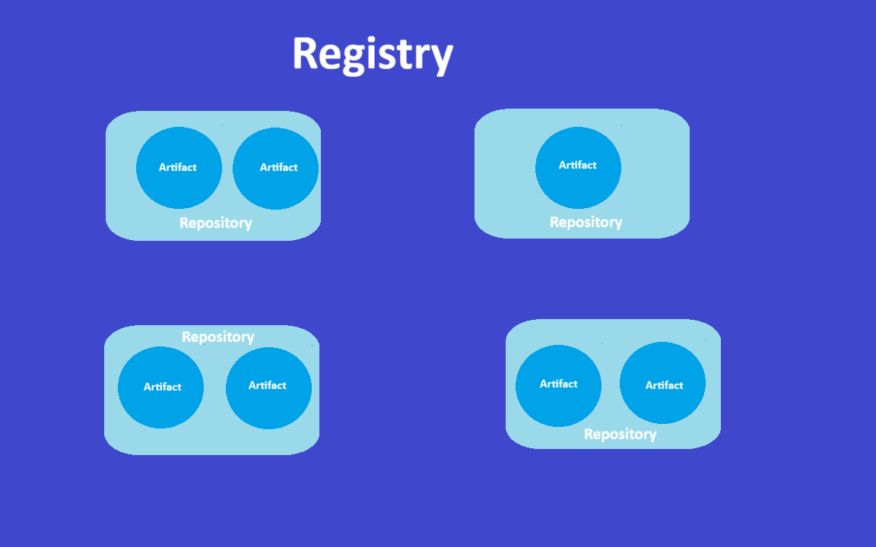
Figure 1 ACR Hierarchy

Registry
The registry is the top label resource of ACR that hosts all container content. Each registry has its own URL with the <registry-name>.azurecr.io format you will use to access both the UI and the resources inside the registry. So basically, if you create a registry called “test” the URL for accessing the resource will be test.azurecr.io.
It contains multiple repositories and provides authentication, access control and management capabilities such as configure access to push and pulls, retention policies and geo-replication at registry level.

Repository
The repository is a set of container images with the same name but different tags (versions). For example, inference-api:v1 is a different image from inference-api:v2, but both are from the inference-api repository.
They also provide namespaces with the purpose of organizing the different artifacts and controlling access to them. For instance, you could create a ml-team namespace, a stage namespace and a production namespace and configure separate privileges and permissions for each of them.

Artifact
Artifacts are the actual content stored in the registry.
An artifact can be:
- A Docker container image
- Helm charts
- Any OCI-compliant content
Each artifact has tags identifying it, layers that make up its content and a manifest describing its structure. We will address each of them separately:

Tags
They identify the exact version of an artifact within a repository using the convention artifact:tag, for example qwen:2.0.0, where qwen is the artifact and 2.0.0 is the tag/version of the artifact. It doesn’t have to be only numbers, you could create a inference-engine:stable image, for example. If you pull or push it without specifying the tag, Docker will use latest tag by default, a tag used for referring to the lastest artifact pushed.
Even though images are mutable (when you push an image with an existing tag, the tag moves to point to the latest image) it is recommended to use different tags for each image.

Layers
Each layer corresponds to an instruction in the Dockerfile that modifies the file system:
FROM python:3.11 -> Layer 1
RUN pip install fastapi -> Layer 2
COPY app.py /app/app.py -> Layer 3
CMD ["python", "/app/app.py"] -> Layer 4
They are content-addressable, meaning they can be identified by a hash of their content.
They are useful since ACR uses common layers across images, reducing storage costs and speeding up pulls. For example, when multiple images share a base layer such as python:3.11, only one copy exists, and already executed layers are stored in cache, so if you already have pulled an image, the second time you build the Dockerfile, it will be way faster as long as it’s still cached.

Manifest
It contains the layers and configuration of the image as well as extra date such as size and digest, basically, the SHA256 identifier of an image in the sha256:abc123 format. Digests are immutable, once an image is pushed, its digest cannot change.

Artifacts addressing
ACR provides two ways of referring to an image:

By tag
You use the registry, the artifact and the tag to refer to the image using the registry/artifact:tag format:
docker pull myregistry.azurecr.io/inference-api:v1.2.0
docker push myregistry.azurecr.io/inference-api:v1.2.0

By digest
You also can use the digest, making use of the registry/repository@sha256:hash format to reference to the specific and immutable image regardless of tag changes:
docker pull myregistry.azurecr.io/inference-api@sha256:0a2e01852872580b2c2fea9380ff8d7b637d3928783c55beb3f21a6e58d5d108
This is well-fitted for production workloads where you need guaranteed reproducibility and consistency. You can get an image’s digest using Azure portal, Azure CLI or from the output when pushing an image.

Best practices
- Use namespaces: Organize repositories by teams, environment or project using forward-slash notation, make it easier to find related repositories and simplify access control.
- Plan repository structure: Group related images logically considering deployment patterns, team ownership or lifecycle management needs.
- Enable geo-replication: For global workloads, replicate images across regions to reduce pull latency and improve deployment reliability.
- Monitor storage: Track storage consumption and implement retention policies to remove untagged manifests and outdated images. Cleanup policies might avoid unnecessary storage costs.

ACR Tasks
ACR Tasks is a suite of features that offload container image building to Azure, abstracting you from:
- Getting Docker installed locally.
- Build the images locally.
- Push the local images to ACR.
You push instead the source code to ACR and let Azure handle the build process. Using ACR Tasks might get you the following benefits:
- Consistent builds: Eliminate the “it works in my machine” problems, the builds are executed in the same, controlled environments and infrastructure.
- No local Docker required: It builts images from the source code without installing Docker in developer workstations, simplifying development setups and enabling builds from environments where Docker is not available.
- CI/CD integration: You can trigger builds automatically from source code commits or image updates. ACR Tasks are also integrated with GitHub Actions and Azure Pipelines.
ACR Tasks supports three main scenarios: quick tasks for on-demand builds, automatically triggered tasks for continuous integration, and multi-step tasks for complex workflows.

On-demand tasks
You can execute builds on the fly using:
az acr build --registry myregistry --image inference-api:v1.0.0 .
This command will use the Dockerfile in the build context (specified in this case by the period (.) argument, meaning the current directory) to build an image called inference-api:v1.0.0 and place it in the myregistry registry.
The build context can be a local directory, but it isn’t limited to this, they could also be remote repositories or even compressed archives exposed on a remote web server via URL:
az acr build --registry myregistry --image inference-api:v1.0.0 https://github.com/myorg/inference-api.git

Automatically triggered tasks
You can also set up an ACR task to fire on a specific condition change:
az acr task create --registry myregistry --name build-inference-api --image inference-api:{{.Run.ID}} --context https://github.com/myorg/inference-api.git#main --file Dockerfile --git-access-token $PAT
This command creates a build action called build-inference-api that creates an image called inference-api:v where v is a unique tag generated from the {{.Run.ID}} syntax on the run. The context is the context https://github.com/myorg/inference-api.git repository, and is set to fire on pushes to main branch (#main). The file to base the build in is the Dockerfile and finally, we pass the $PAT variable (consisting of the actual GitHub PAT) to grant ACR permissions to access and create webhooks that will fire when the event happens.

Base image triggers
These triggers automatically rebuild application images when their base image updates.
For example, when you update a base image used by another image as base (using the FROM statement in the Dockerfile), ACR detects the change and automatically rebuilds all the images that specify that base image. This automation ensures your images receive security patches and updates from base images with no manual intervention.
However, both images (the base and the dependent) should be in the same registry so the rebuild be able to be triggered.

Scheduled triggers
You can also configure triggers that will run regularly on the schedule:
az acr task create --registry myregistry --name nightly-build --image inference-api:nightly --context https://github.com/myorg/inference-api.git --schedule "0 0 * * *" --file Dockerfile --git-access-token $PAT

Multi-steps tasks
You can set up multi-step tasks by defining a YAML file like this:
version: v1.1.0
steps:
- build: -t {{.Run.Registry}}/inference-api:{{.Run.ID}} .
- push:
- {{.Run.Registry}}/inference-api:{{.Run.ID}}
- cmd: {{.Run.Registry}}/inference-api:{{.Run.ID}} python -m pytest tests/
This YAML defines a tasks that builds a myregistry/inference-api:x using the {{.Run.Registry}} syntax to refer the registry name as well as an unique tag using the run ID syntax. Run the tests and push it to registry.
Multi-step tasks support:
- Build and test workflows that validate images before pushing
- Sequential operations with dependencies between steps
- Parallel execution of independent steps

Conditional logic based on previous step results
After defined you can simply run it specifying the YAML file in the --file argument:
az acr task create --registry myregistry --name build-test-push --context https://github.com/myorg/inference-api.git --file acr-task.yaml --git-access-token $PAT

Run images for testing
ACR Tasks can build an image to validate it works correctly and catch configuration issues before deployment using the command run:
az acr run --registry myregistry --cmd 'inference-api:v1.0.0 python --version' /dev/null
The /dev/null context indicates no source files are needed since you're running an existing image. Use this approach to:
- Verify an image starts correctly
- Check that required tools and frameworks are available
- Execute health check commands

Best practices
- Use run variables: Incorporate {{.Run.ID}} or {{.Run.Date}} in tags for unique, traceable builds. These variables create distinct tags that link images to specific task runs.
- Secure access tokens: Store personal access tokens for Git triggers in Azure Key Vault. Avoid committing tokens to repositories or including them in scripts.
- Monitor task logs: Review task output to diagnose build failures using az acr task logs. Logs show the complete build process including any errors.
- Optimize build context: Use .dockerignore to exclude unnecessary files from the context upload. Large contexts slow down builds and consume bandwidth.
- Layer caching: ACR Tasks cache layers between builds. Order Dockerfile instructions to maximize cache hits by placing frequently changing instructions late in the file.

